
DEPARTMENT OF COMMERCE
FINANCIAL SUPPORT TO POOR STUDENTS: 27.3.2022

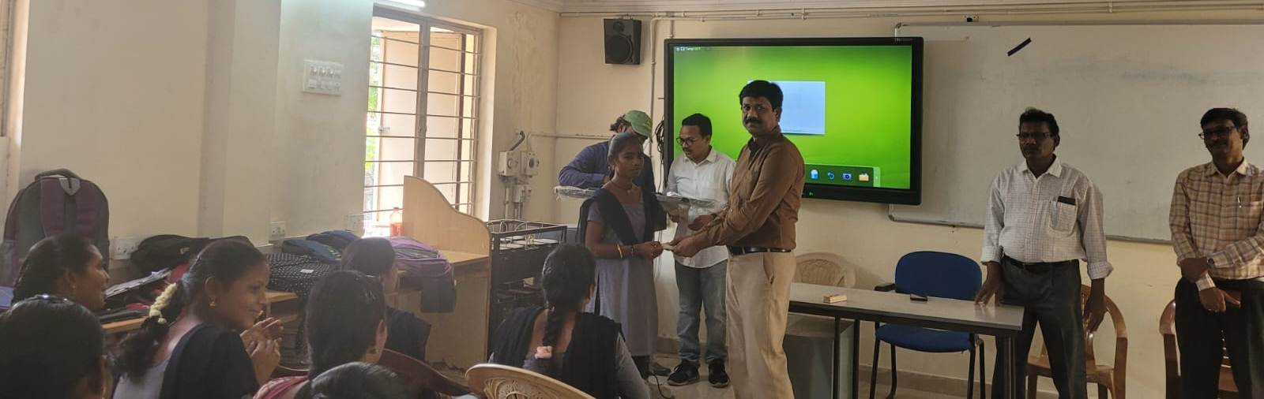



DEPARTMENT OF COMMERCE
FINANCIAL SUPPORT TO POOR STUDENTS: 27.3.2022



DEPARTMENT OF COMMERCE
FINANCIAL SUPPORT TO POOR STUDENTS: 27.3.2022
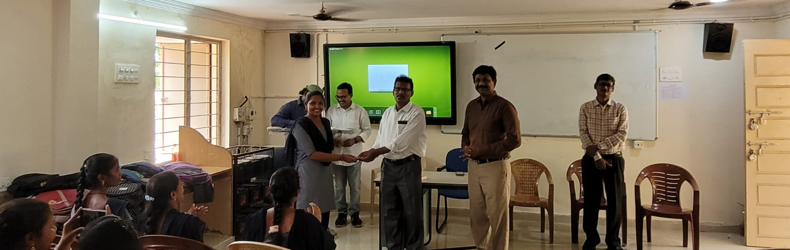



DEPARTMENT OF COMMERCE
FINANCIAL SUPPORT TO POOR STUDENTS: 27.3.2022

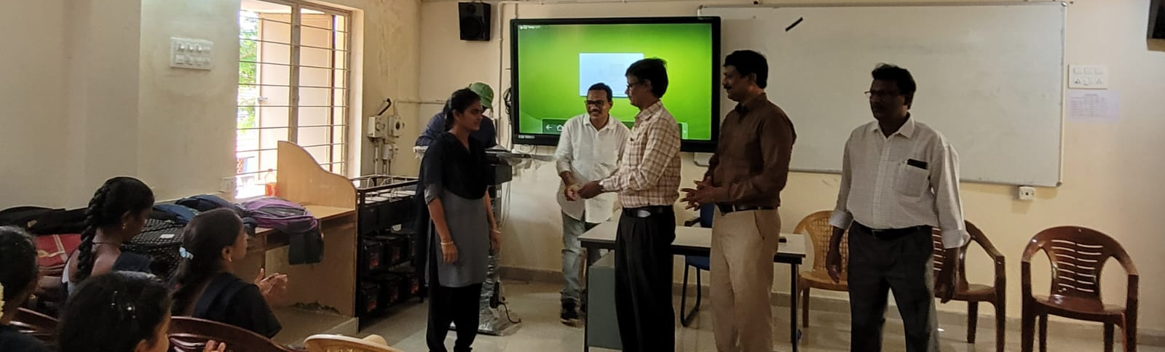
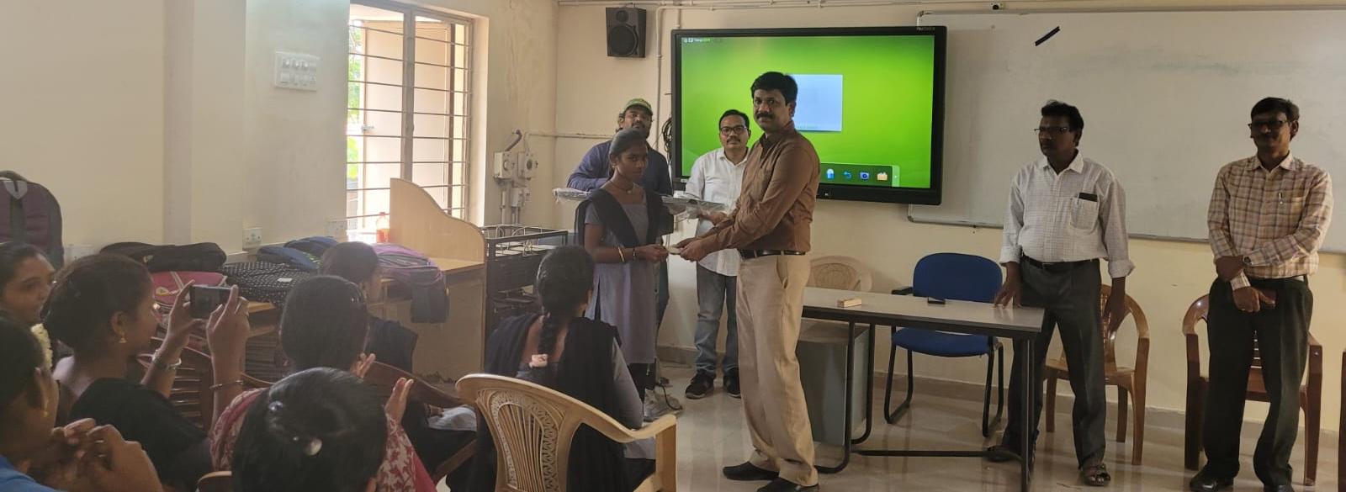

DEPARTMENT OF COMMERCE
FINANCIAL SUPPORT TO POOR STUDENTS: 07.7.22

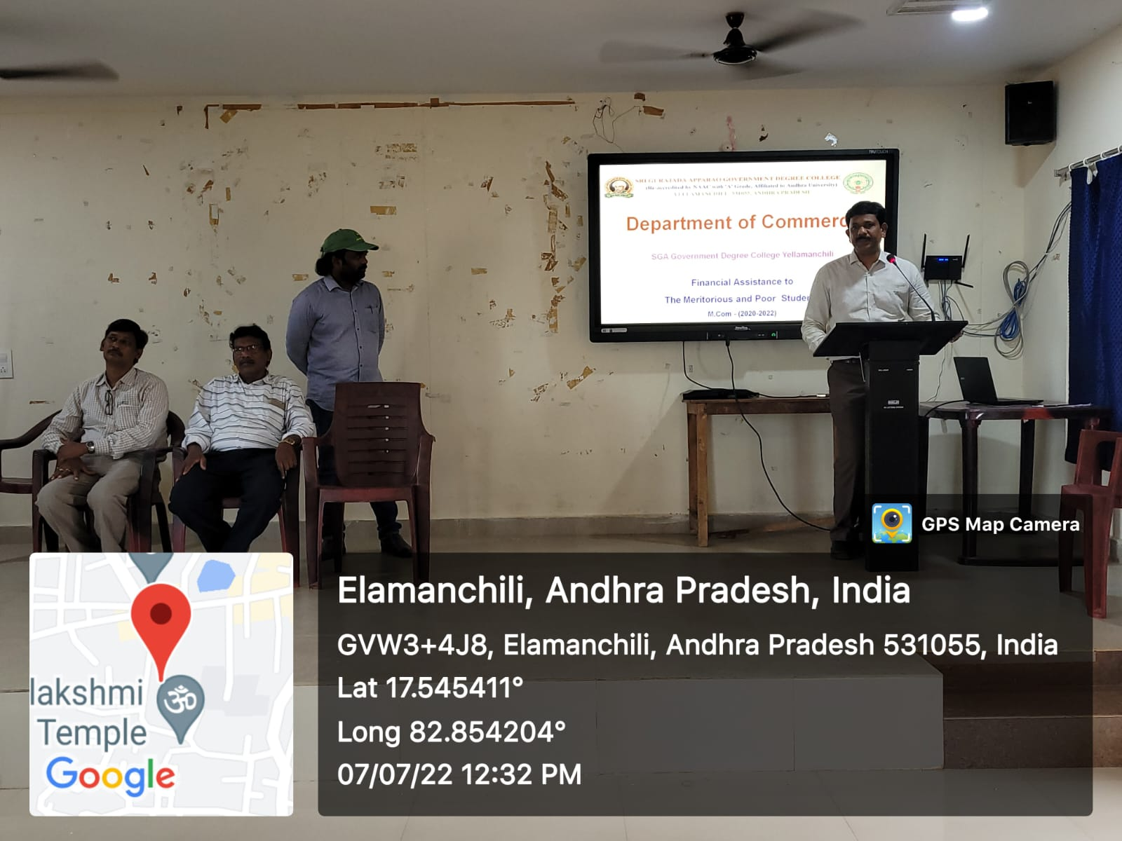


DEPARTMENT OF COMMERCE
FINANCIAL SUPPORT TO POOR STUDENTS: 07.7.22




